Instructions
Part 1: Make your monster
- Draw/create your monster
- Choose the parts of your drawing that you want to be interactive and cut them out;
  - NOTE: You can have anywhere between 2 and 5 interactive points
- Fold the aluminum foil and sticky tape it to the back of your drawing behind each of the holes. This will make the buttons;
  - NOTE: The foil for each button must not touch
- Fold a piece of aluminum foil and attach it to the bottom of your paper to make a START button;
- Use the copper tape to connect the aluminium foil to the edge of the paper;
  - NOTE: Do not overlap your copper tape. This will affect your circuit
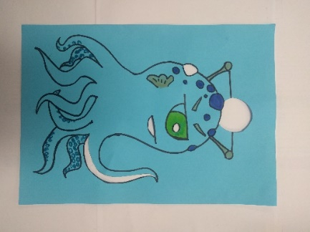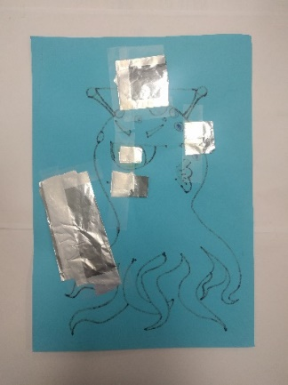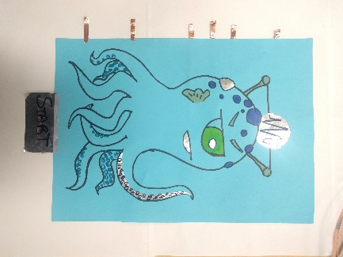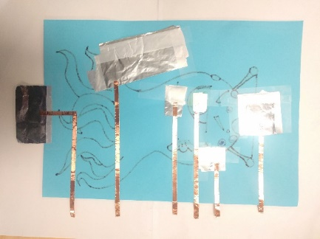

Part 2: Connect the Makey Makey
- Plug the Makey Makey into the USB port on your computer;
- Attach an alligator clip between the 'earth' bar and the 'start' button on your monster;
- Connect the arrow buttons and the 'space' button to the other tabs on your monster;

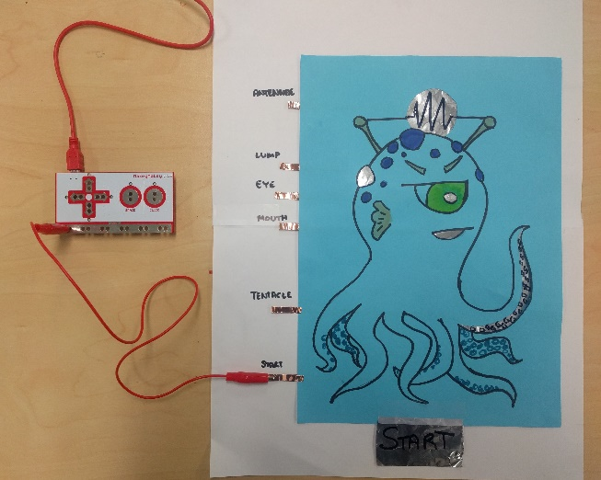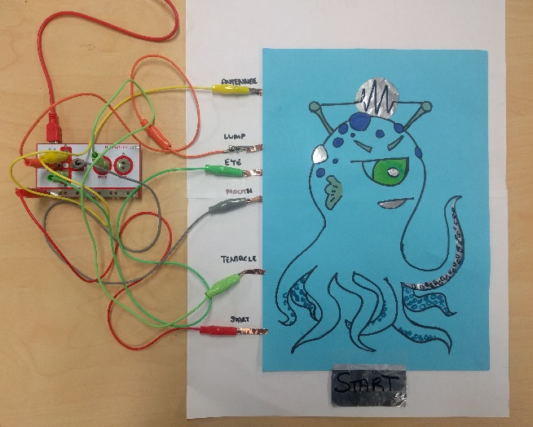

Part 3: Time to code!
The Makey Makey tells your computer to press certain buttons. Scratch is what you use to tell the computer what to do when those buttons are pushed.
- Go to https://scratch.mit.edu/;
- Click ‘create’ in the top left corner;
- In the centre, you'll see tabs for different types of scripts. Click on the ‘events’ menu;
- Drag the event over to the workspace on the right;
- You'll need one of these for each sound/foil/button you're using. Use the drop-down on each script to select which button it relates to;
- Next, click on the ‘scripts’ menu and connect a script to each of your event scripts;
Now we need to choose what sounds each button will make
- Click on the ‘Sounds’ tab next to the ‘scripts’ and ‘costumes’ tab;
  - To choose a sound from the library, click the button
  - To record your own sound, click the button
  - To upload a sound file, click the button
- Double-click the sound you want to use and it will be added to the project;
- Go back to the ‘scripts’ tab. Click on the drop-down on the scripts and choose your sound from the list for each button.

